ASSIGNMENT - 7
Title: Write a program to implement Simplified Data Encryption Standard (SDES) Algorithm and write a conclusion on the strength of SDES.

Theory

What is SDES?
The Simplified Data Encryption Standard (SDES) is a "toy" block cipher created for educational purposes. It was developed by Professor Edward Schaefer of Santa Clara University to help students understand the fundamental principles of modern symmetric-key ciphers, specifically the Data Encryption Standard (DES), without the overwhelming complexity of the real algorithm.
SDES mimics the Feistel (or "F-box") structure of DES but operates on a much smaller scale:
- Block Size: 8-bit blocks of data (compared to 64-bit for DES).
- Key Size: 10-bit master key (compared to 56-bit for DES).
- Rounds: 2 rounds of encryption (compared to 16 for DES).
- Subkeys: Generates two 8-bit subkeys (K1 and K2) from the 10-bit master key.
The encryption process involves an initial permutation (IP), two rounds of a Feistel function (which includes permutation, expansion, S-box substitution, and XOR operations), a swap, and a final inverse permutation (IP⁻¹).

Example
Let's encrypt an 8-bit plaintext block with a 10-bit key.
- Plaintext (P): 10101010
- Master Key (K): 1010000010

Step 1: Key Generation
First, we generate the two 8-bit subkeys, K1 and K2.
- P10 Permutation: Apply the P10 table {2, 4, 1, 6, 3, 9, 0, 8, 7, 5} to the key 1010000010.
  - Key[2] Key[4] Key[1] Key[6] Key[3] Key[9] Key[0] Key[8] Key[7] Key[5]
  - 1 0 0 0 0 0 1 1 0 0 -> 1000001100
- Split: Split the 10-bit result into two 5-bit halves.
  - Left (L): 10000
  - Right (R): 01100
- LS-1 (Left Shift 1): Perform a 1-bit circular left shift on both halves.
  - L_ls1: 00001
  - R_ls1: 11000
- P8 Permutation (K1): Combine the shifted halves (0000111000) and apply the P8 table {5, 2, 6, 3, 7, 4, 9, 8} to get K1.
  - Input[5] Input[2] Input[6] Input[3] Input[7] Input[4] Input[9] Input[8]
  - 1 0 1 0 0 1 0 0 -> 10100100
  - K1 = 10100100
- LS-2 (Left Shift 2): Perform a 2-bit circular left shift on the already shifted halves (L_ls1 and R_ls1).
  - L_ls2: 00100 (from 00001)
  - R_ls2: 00011 (from 11000)
- P8 Permutation (K2): Combine these new halves (0010000011) and apply the P8 table {5, 2, 6, 3, 7, 4, 9, 8} to get K2.
  - Input[5] Input[2] Input[6] Input[3] Input[7] Input[4] Input[9] Input[8]
  - 0 1 0 0 0 0 1 1 -> 01000011
  - K2 = 01000011

Step 2: Encryption
Now we encrypt the plaintext 10101010 using K1 and K2.
- Initial Permutation (IP): Apply the IP table {1, 5, 2, 0, 3, 7, 4, 6} to the plaintext 10101010.
  - P[1] P[5] P[2] P[0] P[3] P[7] P[4] P[6]
  - 0 0 1 1 0 0 1 1 -> 00110011
- Split: Split the result into L0 and R0.
  - L0: 0011
  - R0: 0011
Round 1 (using K1 = 10100100)
- Feistel Function (Fk) on R0:
  - E/P: Expand R0 (0011) using the E/P table {3, 0, 1, 2, 1, 2, 3, 0}.
    - R0[3] R0[0] R0[1] R0[2] R0[1] R0[2] R0[3] R0[0]
    - 1 0 0 1 0 1 1 0 -> 10010110
  - XOR: XOR the result with K1.
    - 10010110 (E/P result)
    - 10100100 (K1)
    - --------
    - 00110010
  - S-Boxes: Split the 8-bit result (00110010) into two 4-bit parts.
    - S0 Input: 0011. Row=01(1), Col=01(1). S0[1][1] = 2 (10).
    - S1 Input: 0010. Row=00(0), Col=01(1). S1[0][1] = 1 (01).
  - Combine: Combine S-Box outputs: 10 + 01 -> 1001.
  - P4: Apply the P4 table {1, 3, 2, 0} to 1001.
    - Input[1] Input[3] Input[2] Input[0]
    - 0 1 0 1 -> 0101
  - Fk Result = 0101
- End of Round 1:
  - L1 = L0 XOR Fk = 0011 XOR 0101 = 0110
  - R1 = R0 = 0011
Round 2 (using K2 = 01000011)
- Swap: The input to Round 2 is (R1, L1) -> (0011, 0110).
  - L_in: 0011
  - R_in: 0110
- Feistel Function (Fk) on R_in:
  - E/P: Expand R_in (0110) using the E/P table {3, 0, 1, 2, 1, 2, 3, 0}.
    - R_in[3] R_in[0] R_in[1] R_in[2] R_in[1] R_in[2] R_in[3] R_in[0]
    - 0 0 1 1 1 1 0 0 -> 00111100
  - XOR: XOR the result with K2.
    - 00111100 (E/P result)
    - 01000011 (K2)
    - --------
    - 01111111
  - S-Boxes: Split the 8-bit result (01111111) into two 4-bit parts.
    - S0 Input: 0111. Row=01(1), Col=11(3). S0[1][3] = 0 (00).
    - S1 Input: 1111. Row=11(3), Col=11(3). S1[3][3] = 3 (11).
  - Combine: Combine S-Box outputs: 00 + 11 -> 0011.
  - P4: Apply the P4 table {1, 3, 2, 0} to 0011.
    - Input[1] Input[3] Input[2] Input[0]
    - 0 1 1 0 -> 0110
  - Fk Result = 0110
- End of Round 2: (No final swap)
  - L2 = L_in XOR Fk = 0011 XOR 0110 = 0101
  - R2 = R_in = 0110
- Final Combination: Combine L2 and R2: 01010110.
- Inverse IP (IP⁻¹): Apply the IP⁻¹ table {3, 0, 2, 4, 6, 1, 7, 5} to 01010110.
  - Input[3] Input[0] Input[2] Input[4] Input[6] Input[1] Input[7] Input[5]
  - 1 0 0 0 1 1 0 1 -> 10001101
Final Ciphertext: 10001101

Steps to Execution
To compile and run the provided C++ program:
- Save the Code: Save the program code (from Section 7) as sdes.cpp.
- Open Terminal: Open a command-line terminal or shell.
- Navigate to Directory: Use the cd command to navigate to the directory where you saved sdes.cpp.
- Compile: Use a C++17 compatible compiler (like g++) to compile the program.
g++ sdes.cpp -o sdes -std=c++17
- Run: Execute the compiled program.
  - On macOS/Linux: ./sdes
  - On Windows: sdes.exe
- Use the Menu:
  - Enter 1 to Encrypt.
  - Enter 2 to Decrypt.
  - Enter 3 to Exit.
- Follow Prompts: The program will ask for a 10-bit key and an 8-bit plaintext/ciphertext. Enter the bits as a single string (e.g., 1010000010).

Technical Stack
- Programming Language: C++ (specifically, C++17 for features like structured bindings).
- Standard Libraries:
  - <iostream>: For handling console input and output (cin, cout, endl).
  - <string>: For using the std::string class to manage bit strings.
  - <vector>: For standard vector operations (though not heavily used in the final version).
  - <algorithm>: For the std::rotate function used in circularLeftShift.
  - <cctype>: For the isdigit function to validate menu input.
- Compiler: g++ (or any C++17 compatible compiler like Clang or MSVC).
- Execution Environment: A standard command-line terminal (like Bash, Zsh, or Windows Command Prompt).

Conclusion
This project successfully implements the Simplified Data Encryption Standard (SDES) in C++ as a command-line application. The program correctly generates subkeys (K1, K2) from a 10-bit master key and performs both encryption and decryption of 8-bit blocks using the algorithm's Feistel structure. The menu-driven interface makes it easy to test and verify the cipher's functionality.

On the Strength of SDES
The user's prompt specifically asked for a conclusion on the strength of SDES.
In short: SDES has no cryptographic strength and is profoundly insecure. It should never be used for any real-world data protection.
Its weaknesses are fundamental and intentional, making it a "toy cipher" suitable only for academic study:
- Vulnerability to Brute-Force Attack: The key size is only 10 bits. This means there are only 2^10, or 1024, possible keys. A modern laptop could try every single key (a "brute-force" attack) in less than a millisecond. This is the most glaring and critical weakness.
- Small Block Size: An 8-bit block size is far too small. If one were to encrypt text (e.g., ASCII, where each character is 8 bits), an attacker could easily build a "codebook" by mapping common characters (like 'e', 't', 'a') to their corresponding ciphertext. Frequency analysis would make breaking the cipher trivial.
- Insufficient Rounds: The algorithm uses only two rounds. This is insufficient to provide adequate "confusion" and "diffusion" (the two key principles of modern ciphers defined by Claude Shannon). The relationship between the plaintext, key, and ciphertext is too simple, making it highly susceptible to analytical attacks like linear and differential cryptanalysis.
While SDES is a failure as a secure cipher, it is a resounding success as an educational tool. It provides a tangible, simple, and hand-calculable way to understand the complex, layered operations—such as permutations, S-box substitutions, and key scheduling—that form the basis of robust, real-world ciphers like AES (Advanced Encryption Standard).

CODE:
#include <iostream>
#include <string>
#include <vector>
#include <algorithm>
#include <cctype> // For isdigit

using namespace std;

// --- S-DES Permutation and S-Box Definitions ---
// Note: These are 0-indexed for direct array access.

// P10 (Permute 10)
const int P10[] = {2, 4, 1, 6, 3, 9, 0, 8, 7, 5};
// P8 (Permute 8)
const int P8[] = {5, 2, 6, 3, 7, 4, 9, 8};
// P4 (Permute 4)
const int P4[] = {1, 3, 2, 0};

// IP (Initial Permutation)
const int IP[] = {1, 5, 2, 0, 3, 7, 4, 6};
// IP Inverse
const int IP_inv[] = {3, 0, 2, 4, 6, 1, 7, 5};

// E/P (Expansion/Permutation)
const int EP[] = {3, 0, 1, 2, 1, 2, 3, 0};

// S-Box 0
const int S0[4][4] = {
{1, 0, 3, 2},
{3, 2, 1, 0},
{0, 2, 1, 3},
{3, 1, 3, 2}
};

// S-Box 1
const int S1[4][4] = {
{0, 1, 2, 3},
{2, 0, 1, 3},
{3, 0, 1, 0},
{2, 1, 0, 3}
};

string permute(const string& input, const int table[], size_t outSize) {
string output(outSize, '0');
for (size_t i = 0; i < outSize; ++i) {
output[i] = input[table[i]];
}
return output;
}

string circularLeftShift(string data, int nBits) {
rotate(data.begin(), data.begin() + nBits, data.end());
return data;
}

pair<string, string> split(const string& input) {
size_t const N = input.length();
return { input.substr(0, N / 2), input.substr(N / 2) };
}

string combine(const string& left, const string& right) {
return left + right;
}

string xorStrings(const string& s1, const string& s2) {
string result = "";
for (size_t i = 0; i < s1.length(); ++i) {
// (s1[i] - '0') gives 0 or 1
result += ((s1[i] - '0') ^ (s2[i] - '0')) ? '1' : '0';
}
return result;
}

string sBoxLookup(const string& input, const int sbox[4][4]) {
// Row: bits 1 and 4 (string 0-indexed: 0 and 3)
int row = (input[0] - '0') * 2 + (input[3] - '0');

// Col: bits 2 and 3 (string 0-indexed: 1 and 2)
int col = (input[1] - '0') * 2 + (input[2] - '0');

int val = sbox[row][col];

// Convert int (0-3) to 2-bit string
string res = "00";
res[0] = (val & 2) ? '1' : '0'; // MSB
res[1] = (val & 1) ? '1' : '0'; // LSB
return res;
}

pair<string, string> generateKeys(const string& key10) {
// 1. P10
string p10_key = permute(key10, P10, 10);

// 2. Split
auto [left, right] = split(p10_key);

// 3. LS-1
string ls1_left = circularLeftShift(left, 1);
string ls1_right = circularLeftShift(right, 1);

// 4. Combine and P8 -> K1
string k1 = permute(combine(ls1_left, ls1_right), P8, 8);

// 5. LS-2 (on the LS-1 results)
string ls2_left = circularLeftShift(ls1_left, 2);
string ls2_right = circularLeftShift(ls1_right, 2);

// 6. Combine and P8 -> K2
string k2 = permute(combine(ls2_left, ls2_right), P8, 8);

return {k1, k2};
}

string feistelFunction(string data, const string& key) {
// 1. E/P
string expanded = permute(data, EP, 8);

// 2. XOR with key
expanded = xorStrings(expanded, key);

// 3. Split
auto [s0_in, s1_in] = split(expanded);

// 4. S-Boxes
string s0_out = sBoxLookup(s0_in, S0);
string s1_out = sBoxLookup(s1_in, S1);

// 5. Combine
string s_out = combine(s0_out, s1_out);

// 6. P4
return permute(s_out, P4, 4);
}

string sdes_transform(const string& input, const string& k1, const string& k2) {
// 1. Initial Permutation (IP)
string ip_out = permute(input, IP, 8);
auto [left, right] = split(ip_out);

// 2. Round 1 (Fk with K1)
string f1_res = feistelFunction(right, k1);
string r1_left = xorStrings(left, f1_res);
string r1_right = right;

// 3. Swap (L and R for next round)
// new left is r1_right, new right is r1_left

// 4. Round 2 (Fk with K2)
string f2_res = feistelFunction(r1_left, k2);
string r2_left = xorStrings(r1_right, f2_res);
string r2_right = r1_left;

// 5. Combine
string combined = combine(r2_left, r2_right);

// 6. Inverse IP
return permute(combined, IP_inv, 8);
}

bool isValidBitString(const string& s, int n) {
if (s.length() != n) {
return false;
}
for (char c : s) {
if (c != '0' && c != '1') {
return false;
}
}
return true;
}

string getValidBitString(const string& prompt, int n) {
string input;
while (true) {
cout << prompt;
getline(cin, input);
if (isValidBitString(input, n)) {
return input;
}
cout << "Invalid input. Please enter exactly " << n << " bits (0s or 1s).\n";
}
}

void showMenu() {
cout << "\n--- Simplified DES (S-DES) ---" << endl;
cout << "1. Encrypt" << endl;
cout << "2. Decrypt" << endl;
cout << "3. Exit" << endl;
cout << "Enter your choice: ";
}

int main() {
int choice;
do {
showMenu();
string choiceStr;
getline(cin, choiceStr);

// Replaced stoi with simple check to avoid exceptions
if (choiceStr.length() == 1 && isdigit(choiceStr[0])) {
choice = choiceStr[0] - '0'; // Convert char to int
} else {
choice = -1; // Invalid choice
}

if (choice == 1 || choice == 2) {
string key_str = getValidBitString("Enter 10-bit key: ", 10);
string key = key_str;

// Generate subkeys
auto [k1, k2] = generateKeys(key);
cout << "Generated K1: " << k1 << endl;
cout << "Generated K2: " << k2 << endl;

if (choice == 1) {
// Encrypt
string plain_str = getValidBitString("Enter 8-bit plaintext: ", 8);
string plaintext = plain_str;

// For encryption, use (K1, K2)
string ciphertext = sdes_transform(plaintext, k1, k2);

cout << "\nPlaintext: " << plaintext << endl;
cout << "Ciphertext: " << ciphertext << endl;
} else {
// Decrypt
string cipher_str = getValidBitString("Enter 8-bit ciphertext: ", 8);
string ciphertext = cipher_str;

// For decryption, use (K2, K1)
string plaintext = sdes_transform(ciphertext, k2, k1);

cout << "\nCiphertext: " << ciphertext << endl;
cout << "Plaintext: " << plaintext << endl;
}
} else if (choice == 3) {
cout << "Exiting..." << endl;
} else {
cout << "Invalid choice. Please enter 1, 2, or 3." << endl;
}
} while (choice != 3);

return 0;
}

OUTPUT:
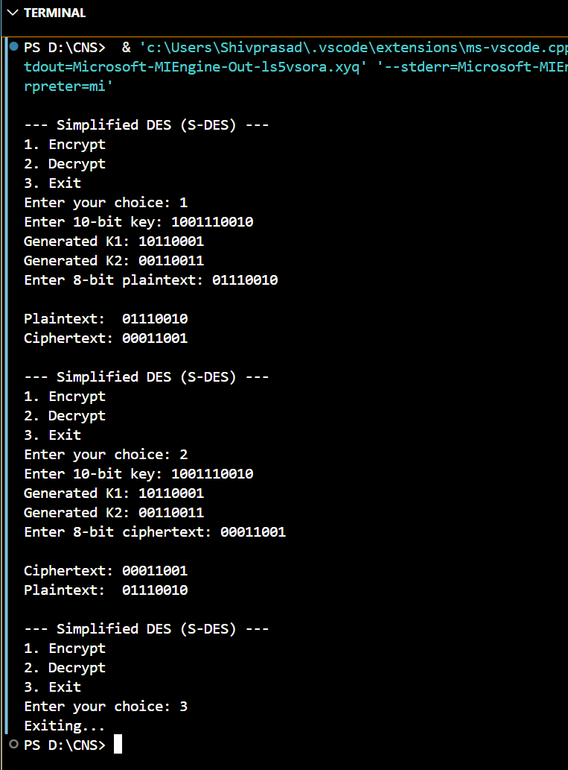
Name: Shivprasad A. Mahind
PRN: 123B1B266
Batch: D3

